Impacts of Social Media on Society

# Is there a correlation between suicide rate and media usage?

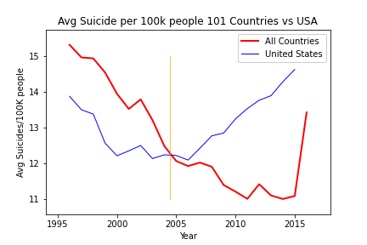

While other countries suicide rates show a downward trend, the United States shows a sharp increase starting around the introduction of Social Media.

# Is the impact different by the age of individuals?

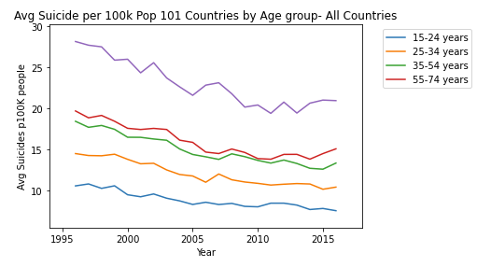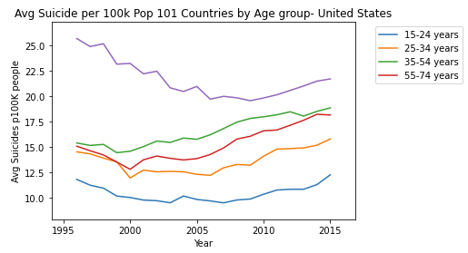

Little correlation exists between suicide rate and social media across the age groups when viewing data across all countries. When focusing on the United States, suicide rate shows a slight increasing trend starting around 2000 for all age groups except for group 75+. The increasing trend starts just before the start of social media. The data does show that suicide rate increases as age of individual increases.

# Is the impact different between generations?

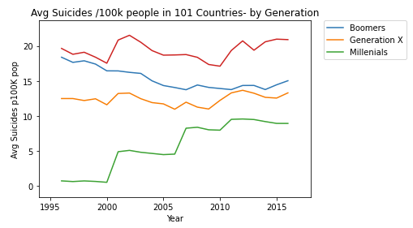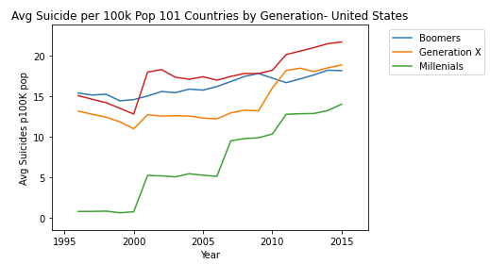

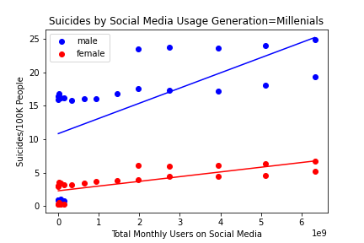

Based on our data, we can see that younger generations are more impacted by social media usage. Both Millennials and Generation X showed an increase in suicide rates starting around the start of social media. A statistical analysis of the Pearson correlation coefficient determined that there was a high statistical correlation between users on social media and suicide rate for Generation X, Millennials, and Generation Z.

# Which countries seem to be impacted more by social media?

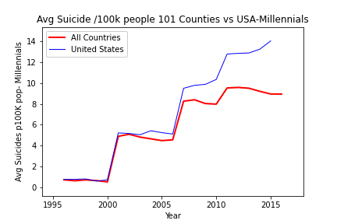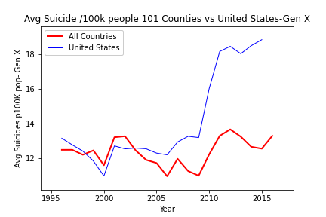

As mentioned in an earlier graph, we determined that the United States seems to be impacted more by social media. The two graphs above show a much steeper increase in suicide rate across the data set for the US compared to the other countries. For Generation X, we can see a significant increase in suicide rate around 2009, which correlates to the year that Facebook became popular across the United States.

# Is the impact different by gender?

Suicides in males is more prevalent than in females, access to social media might be a factor. When looking at data for Millennials, suicide rate increased at a much faster rate compared to females since the start of social media.